|  |  |  |  |  |  |
| --- | --- | --- | --- | --- | --- |
| **Prepared For:** | **Your Name** | | | | |
|  | (Name of Client) | | | | |
| **Concerning:** | **Property Address** | | | | |
|  | (Address or Other Identification of Inspected Property) | | | | |
| **By:** | **Rick Runnels, #873** | |  | | |
|  | | (Name and License Number of Inspector) | | (Date) |
|  | **Brandon Runnels, #9809** | | | | |
|  | | (Name, License Number and Signature of Sponsoring Inspector, if required) | | | |

**PURPOSE, LIMITATIONS AND INSPECTOR / CLIENT RESPONSIBILITIES**

This property inspection report may include an inspection agreement (contract), addenda, and other information related to property conditions. If any item or comment is unclear, you should ask the inspector to clarify the findings. It is important that you carefully read ALL of this information.

This inspection is subject to the rules (“Rules”) of the Texas Real Estate Commission (“TREC”), which can be found at [www.trec.texas.gov](http://www.trec.texas.gov).

The TREC Standards of Practice (Sections 535.227-535.233 of the Rules) are the minimum standards for inspections by TREC licensed inspectors. An inspection addresses only those components and conditions that are present, visible, and accessible at the time of the inspection. While there may be other parts, components or systems present, only those items specifically noted as being inspected were inspected. The inspector is NOT required to turn on decommissioned equipment, systems, utility services or apply an open flame or light a pilot to operate any appliance. The inspector is NOT required to climb over obstacles, move furnishings or stored items. The inspection report may address issues that are code-based or may refer to a particular code; however, this is NOT a code compliance inspection and does NOT verify compliance with manufacturer’s installation instructions. The inspection does NOT imply insurability or warrantability of the structure or its components. Although some safety issues may be addressed in this report, this inspection is NOT a safety/code inspection, and the inspector is NOT required to identify all potential hazards.

In this report, the inspector shall indicate, by checking the appropriate boxes on the form, whether each item was inspected, not inspected, not present or deficient and explain the findings in the corresponding section in the body of the report form. The inspector must check the Deficient (D) box if a condition exists that adversely and materially affects the performance of a system or component or constitutes a hazard to life, limb or property as specified by the TREC Standards of Practice. General deficiencies include inoperability, material distress, water penetration, damage, deterioration, missing components, and unsuitable installation. Comments may be provided by the inspector whether or not an item is deemed deficient. The inspector is not required to prioritize or emphasize the importance of one deficiency over another.

Some items reported may be considered life-safety upgrades to the property. For more information, refer to Texas Real Estate Consumer Notice Concerning Recognized Hazards or Deficiencies below.

________________________________________________________________________________________________

THIS PROPERTY INSPECTION IS NOT A TECHNICALLY EXHAUSTIVE INSPECTION OF THE STRUCTURE, SYSTEMS OR COMPONENTS. The inspection may not reveal all deficiencies. A real estate inspection helps to reduce some of the risk involved in purchasing a home, but it cannot eliminate these risks, nor can the inspection anticipate future events or changes in performance due to changes in use or occupancy. It is recommended that you obtain as much information as is available about this property, including any seller’s disclosures, previous inspection reports, engineering reports, building/remodeling permits, and reports performed for or by relocation companies, municipal inspection departments, lenders, insurers, and appraisers. You should also attempt to determine whether repairs, renovation, remodeling, additions, or other such activities have taken place at this property. It is not the inspector’s responsibility to confirm that information obtained from these sources is complete or accurate or that this inspection is consistent with the opinions expressed in previous or future reports.

ITEMS IDENTIFIED IN THE REPORT DO NOT OBLIGATE ANY PARTY TO MAKE REPAIRS OR TAKE OTHER ACTIONS, NOR IS THE PURCHASER REQUIRED TO REQUEST THAT THE SELLER TAKE ANY ACTION. When a deficiency is reported, it is the client’s responsibility to obtain further evaluations and/or cost estimates from qualified service professionals. Any such follow-up should take place prior to the expiration of any time limitations such as option periods.

Evaluations by qualified tradesmen may lead to the discovery of additional deficiencies which may involve additional repair costs. Failure to address deficiencies or comments noted in this report may lead to further damage of the structure or systems and add to the original repair costs. The inspector is not required to provide follow-up services to verify that proper repairs have been made. Property conditions change with time and use. For example, mechanical devices can fail at any time, plumbing gaskets and seals may crack if the appliance or plumbing fixture is not used often, roof leaks can occur at any time regardless of the apparent condition of the roof, and the performance of the structure and the systems may change due to changes in use or occupancy, effects of weather, etc. These changes or repairs made to the structure after the inspection may render information contained herein obsolete or invalid. This report is provided for the specific benefit of the client named above and is based on observations at the time of the inspection. If you did not hire the inspector yourself, reliance on this report may provide incomplete or outdated information. Repairs, professional opinions or additional inspection reports may affect the meaning of the information in this report. It is recommended that you hire a licensed inspector to perform an inspection to meet your specific needs and to provide you with current information concerning this property.

**TEXAS REAL ESTATE CONSUMER NOTICE CONCERNING HAZARDS OR DEFICIENCIES**

Each year, Texans sustain property damage and are injured by accidents in the home. While some accidents may not be avoidable, many other accidents, injuries, and deaths may be avoided through the identification and repair of certain hazardous conditions. Examples of such hazards include:

• malfunctioning, improperly installed, or missing ground fault circuit protection (GFCI) devices for electrical

receptacles in garages, bathrooms, kitchens, and exterior areas;

• malfunctioning arc fault protection (AFCI) devices;

• ordinary glass in locations where modern construction techniques call for safety glass;

• malfunctioning or lack of fire safety features such as smoke alarms, fire-rated doors in certain locations, and

functional emergency escape and rescue openings in bedrooms;

• malfunctioning carbon monoxide alarms;

• excessive spacing between balusters on stairways and porches;

• improperly installed appliances;

• improperly installed or defective safety devices; and

• lack of electrical bonding and grounding.

To ensure that consumers are informed of hazards such as these, the Texas Real Estate Commission (TREC) has adopted Standards of Practice requiring licensed inspectors to report these conditions as “Deficient” when performing an inspection for a buyer or seller, if they can be reasonably determined.

These conditions may not have violated building codes or common practices at the time of the construction of the home, or they may have been “grandfathered” because they were present prior to the adoption of codes prohibiting such conditions. While the TREC Standards of Practice do not require inspectors to perform a code compliance inspection,

TREC considers the potential for injury or property loss from the hazards addressed in the Standards of Practice to be significant enough to warrant this notice.

Contract forms developed by TREC for use by its real estate licensees also inform the buyer of the right to have the home inspected and can provide an option clause permitting the buyer to terminate the contract within a specified time. Neither the Standards of Practice nor the TREC contract forms require a seller to remedy conditions revealed by an inspection. The decision to correct a hazard or any deficiency identified in an inspection report is left to the parties to the contract for the sale or purchase of the home.

**INFORMATION INCLUDED UNDER "ADDITIONAL INFORMATION PROVIDED BY INSPECTOR", OR PROVIDED AS AN ATTACHMENT WITH THE STANDARD FORM, IS NOT REQUIRED BY THE COMMISSION AND MAY CONTAIN CONTRACTUAL TERMS BETWEEN THE INSPECTOR AND YOU, AS THE CLIENT. THE COMMISSION DOES NOT REGULATE CONTRACTUAL TERMS BETWEEN PARTIES. IF YOU DO NOT UNDERSTAND THE EFFECT OF ANY CONTRACTUAL TERM CONTAINED IN THIS SECTION OR ANY ATTACHMENTS, CONSULT AN ATTORNEY.**

**ADDITIONAL INFORMATION PROVIDED BY INSPECTOR**

**Notice: This inspection report is subject to the attached contract and handouts**

Inspection Scope  Full

Property inspected was  Vacant

Parties present at inspection  Buyer  Buyers Agent

Buyer’s Agent:

Documents provided to inspector  None

Additional documents provided with the report: Contract Agreement

Weather conditions during inspection  Sunny

Time of inspection:

Outside air temperature during inspection 91 degrees

Additional written information provided with this inspection report by other parties: Yes (WDI Report)

Cost of inspection services $ 400.00 to be paid at  Inspection  Check

________________________________________________________________________________________________

C:\Users\Runnels\AppData\Local\Microsoft\Windows\Temporary Internet Files\Content.IE5\8LN3VDZ1\MC900410517[1].wmf

|  |
| --- |
| **I=Inspected NI=Not Inspected NP=Not Present D=Deficient** |

**I NI NP D**

**I. STRUCTURAL SYSTEMS**

**A. Foundations**

*Type of Foundation(s):*  Slab

This foundation has experienced some differential movement.

It is our opinion that this foundation is structurally functional at this time.

**B. Grading and Drainage**

The soil level should be lowered to provide at least 3-5” of visible slab.

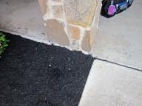

**C. Roof Covering Materials**

Type of Roof Covering:  Composition/Metal

Roof Material Condition:  Average

Viewed from:  Roof

Some feathering was noted along shingle edges.

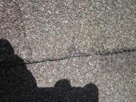

Some “pitting” was noted on the roof (possible hail damage).

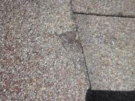

Tree limbs need to be trimmed back at least 4’ from the roof.

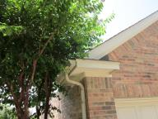

**D. Roof Structures and Attics**

Roof Type  Wood frame

Attic viewed from  Attic

Note: Limited attic inspection due to construction/ductwork/storage (car was blocking access).

Attic ventilation  Soffit vents  Exhaust ports   Gable vents

Depth of Attic Insulation: 8-11 inches

Type:  Blown-in

Vapor Barrier  Visible

The attic insulation needs to be evenly distributed.

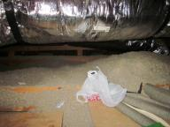

**E. Walls (Interior & Exterior)**

Visible Wall Construction:  Wood framing

Exterior Cladding:  Brick masonry  Stone

General exterior cladding condition: Average (but needs attention)

Note: See also soil level/drainage comments.

Wet spots were noted next to the master bath toilet and utility room.

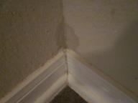 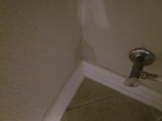

There is a lack of fire separation between the garage and the residence due to the pegboard.

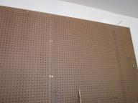

Weep holes are needed above all lintel supports in the brick.

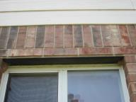

The joints/connections in the hardi-board siding need to be caulked/sealed.

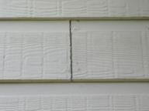

**F. Ceilings and Floors**

There was evidence of water penetration at the utility room and master bath toilet

area. See also comment/photos under wall section.

Lack of fire separation noted between the garage and the residence (attic access/hatch). (In garages that have access to the attic, a hatch cover made from an approved, fire-rated material should protect this access at all times).

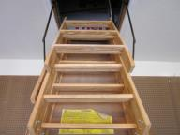

**G. Doors (Interior and Exterior)**

The right walk-in attic door does not fit properly (needs repair).

The door knob to the walk-in attic is missing and needs replacement.

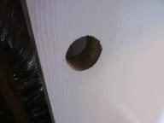

**H. Windows**

Note: See also “weep holes”/lintel comment under wall section.

Lack of functional emergency escape/rescue openings in all sleeping rooms.

There were missing screens noted at the back porch area.

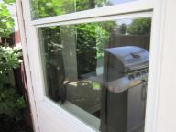

**I. Stairways (Interior and Exterior)**

**J. Fireplaces and Chimneys**

Type of fireplace  Metal Insert

Type of Flue  Metal

Attic Fire-stop  Not Accessible

Chimney Crown  Present

Combustion Air Vent  Present

Chimney observed from:  Roof

Gas Valve / Line  Present

Gas Logs  Present

This gas log-lighter should not be used with gas logs.

**K. Porches, Balconies, Decks, and Carports**

Wood to soil contact was noted at the rear deck, more prone to rot/damage and insects.

**L. Other –** *Comments: Additional information/recommendations provided by the inspector.*

Refer to the contract agreement for any other exclusion. Pictures/summaries imbedded in the report may include some deficiencies found, but not all may be documented by photos/comments (refer to original report findings).

The door to any upstairs walk-in attic should be kept locked for safety reasons.

Note: It is recommended that all locks on exterior entrances be changed for improved security as soon as you take possession of your new home.

**II. ELECTRICAL SYSTEMS**

**A. Service Entrance and Panels**

Wire Type(s) found in Main and Sub Panels:  Copper

Appropriate Connections:  Not Present

Location of Main(s) / Sub Panel(s) / Disconnect(s): exterior

Note: Have an electrician make all needed repairs.

Note: The breaker labeling as very hard to read, recommend re-labeling soon.

Note: ARC fault protection was not present in all appropriate locations (not required on houses built before 2008).

There is a “double-lugged” breaker noted (an additional breaker is needed).

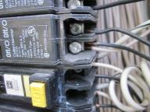

Remove the shrubs from in front of the breaker box.

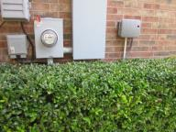

**B. Branch Circuits, Connected Devices, and Fixtures**

Branch circuit wiring  Copper

Grounded 3 wire

Note: Random outlet and switch cover-plates were removed to inspect wiring.

Carbon Monoxide Detectors:  Not Present

Smoke Detectors (recommend replacement of all batteries upon move-in and any older than 10 years old be replaced):  Present

At least one carbon monoxide detector per floor /HVAC zone needs to be installed.

The right walk-in attic light fixture is not properly mounted and also needs a proper light fixture.

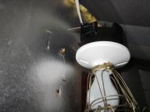

Caulk around all exterior light fixtures.

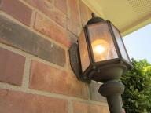

**III. HEATING, VENTILATION AND AIR CONDITIONING SYSTEMS**

**A. Heating Equipment**

*Type of System: Central*

*Energy Source:* Gas

Furnace is  Fully accessible

Gas Shut Off Valve  Present

Branch Line  Iron / Flex

Location: Walk-in Attic Coverage Area: Downstairs 102°

   Location: Upper Attic Coverage Area: Upstairs 109°

The gas drip legs are not present in all appropriate locations on both furnaces.

**B. Cooling Equipment**

*Type of System: Central/Electric*

Unit Manufacture: Goodman & Carrier

Primary condensation drain-line termination point(s): exterior

Coverage: Downstairs Return 75° Supply 63° Δ Temperature 12° (X)

Coverage: Upstairs Return 75° Supply 59° Δ Temperature 16°

Have the entire downstairs HVAC system serviced, cleaned and put into proper working order (including the evaporator coil).

The left primary condensate drain line should be dug up/unblocked (it is buried).

The left primary condensate drain line should be extended at least 3 feet from the slab.

Rust was noted in both HVAC overflow pan.

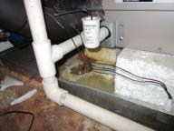

Remove the insulation/debris from the overflow pans of the HVAC units.

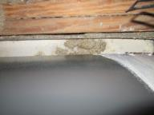

Coil damage was noted on the right condenser (possible hail damage).

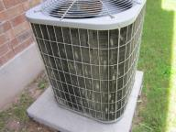

Insulate the primary condensate drain lines across the entire attic for both HVAC systems.

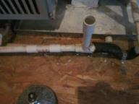

**C. Duct Systems, Chases, and Vents**

Filter Type: removable

Size(s): 14 X 30

There were dirty filters noted for both HVAC systems (recommend changing).

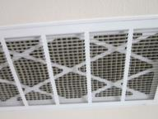

**IV. PLUMBING SYSTEM**

**A. Plumbing Supply, Distribution Systems and Fixtures**

*Location of water meter: Street*

*Location of main water supply valve: Street*

*Type of supply lines*  Copper  Pex

*Air Gap(s)*  Present

*Static water pressure reading (PSI):84 (high)*

Contact your water supplier and see if the meter can be adjusted, install a pressure tank on the water heater and/or a PRV valve.

There was water noted in the wall behind the master bath toilet and the washer connections in the laundry room (have a plumber find the source and make all needed repairs).

The utility hot/cold faucets for the washer are leaking.

The kitchen faucet has a slow drip and will not shut off.

Bath: Master

The left vanity supply handles are mislabeled.

The shower door sweep is missing.

Bath:  Upstairs Hall

The shower head leaks and needs repair/replacement.

Bath:  Half

The vanity supply handle leaks.

**B. Drains, Wastes, and Vents**

Type of Vent Pipe  PVC

**C. Water Heating Equipment**

*Unit Location: Attic*

*Energy Source:*  Gas

*Age: 1998*

*Capacity: 40 Gallons*

*Type/Brand of Water Heater Present: A.O. Smith*

*T & P Valve*  *Not operated (may cause leaks/drips)*

*Safety Pan  Yes*

*Drain Installed* *Yes*

*Gas Shut Off Valve*  *Present*

*Branch Line* *Iron / Flex*

*Type of Observable Vent Pipe* *Double Wall*

Turn down the temperature on the water heater tank as needed (the water temperature should be between 120-125 degrees throughout the house, hazard).

**D. Hydro-Massage Therapy Equipment**

**V. APPLIANCES**

**A Dishwashers**

Rust was noted on the interior and/or dish-racks on this dishwasher.

The dishwasher needs a full anti-syphon loop installed in the drain line to assure that

wastewater does not contaminate the dishwasher.

**B. Food Waste Disposers**

**C. Range Hood and Exhaust Systems**

Vent  Vents to Exterior

**D. Ranges, Cooktops, and Ovens**

Type of Range  Gas

Type of Oven  Gas

Gas Shut Off Valve  Present

Branch Line  Iron / Flex

**E. Microwave Ovens**

**F. Mechanical Exhaust Vents and Bathroom Heaters**

**G. Garage Door Operators**

Door Operated  Wall control

Electronic sensor beams (that cause the door to reverse when tripped) should be installed

not more than 6 inches off of the ground (safety issue).

The garage door locking mechanism should be disabled or removed to prevent accidental damage of the door.

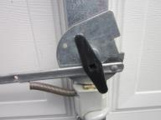

**H. Dryer Exhaust Systems**

Note: We recommend cleaning the dryer vent upon move-in if there is a lint build-up

in the dryer vent (could not determine).

**VI. OPTIONAL SYSTEMS**

**A. Landscape Irrigation (Sprinkler) Systems**

Freeze Sensor  Not Present

Rain Sensor  Not Present/located

Anti-Siphon Valve(s) Present

Back Flow Preventers Present

Shut Off Valve(s) Present

Location of Shutoff Valve: yard

Control Panel located: garage

Number of Zones: 8

The sprinkler heads are over-spraying and need adjustment (over-spraying onto the structure(s), sidewalk(s) and/or any fencing, decks, driveways, etc.).

The control box is damaged.

**B. Other –** *Comments: Additional information provided by the inspector.*

Note: The gas dryer connection was not present, 220 volt only.

The gas meter is not properly grounded/bonded.

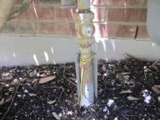

**Summary Page: Property Address**

**I. STRUCTURAL SYSTEMS**

The soil level should be lowered to provide at least 3-5” of visible slab.

Some feathering was noted along shingle edges.

Some “pitting” was noted on the roof (possible hail damage).

Tree limbs need to be trimmed back at least 4’ from the roof.

The attic insulation needs to be evenly distributed.

There is a lack of fire separation between the garage and the residence.

Weep holes are needed above all lintel supports in the brick.

The joints/connections in the hardi-board siding need to be caulked/sealed.

There was evidence of water penetration (wet spots) at the utility room and master bath toilet area.

Lack of fire separation noted between the garage and the residence (attic access/hatch).

The right walk-in attic door does not fit properly (needs repair).

The door knob to the walk-in attic is missing and needs replacement.

Lack of functional emergency escape/rescue openings in all sleeping rooms.

There were missing screens noted at the back porch area.

This gas log-lighter should not be used with gas logs.

Wood to soil contact was noted, more prone to rot/damage and insects.

**II. ELECTRICAL SYSTEMS**

ARC fault protection was not present in all appropriate locations (not required on houses built before 2008).

There is a “double-lugged” breaker noted (an additional breaker is needed).

Remove the shrubs from in front of the breaker box.

At least one carbon monoxide detector per floor /HVAC zone needs to be installed.

The right walk-in attic light fixture is not properly mounted and also needs a proper light fixture.

Caulk around all exterior light fixtures.

**III. HEATING, VENTILATION AND AIR CONDITIONING SYSTEMS**

The gas drip legs are not present in all appropriate locations on both furnaces.

Have the entire downstairs HVAC system serviced, cleaned and put into proper working order (including the evaporator coil).

The left primary condensate drain line should be dug up/unblocked (it is buried).

The left primary condensate drain line should be extended at least 3 feet from the slab.

Rust was noted in both HVAC overflow pan.

Remove the insulation/debris from the overflow pans of the HVAC units.

Coil damage was noted on the right condenser (possible hail damage).

Insulate the primary condensate drain lines across the entire attic for both HVAC systems.

There were dirty filters noted for this HVAC system.

**IV. PLUMBING SYSTEM**

Contact your water supplier and see if the meter can be adjusted, install a pressure tank on the water heater and/or a PRV valve.

There was water noted in the wall behind the master bath toilet and the washer connections in the laundry room (have a plumber find the source and make all needed repairs).

The utility hot/cold faucets for the washer are leaking.

The kitchen faucet has a slow drip and will not shut off.

The left vanity supply handles are mislabeled in the master bath.

The master bath shower door sweep is missing.

The shower head leaks in the upstairs hall bath and needs repair/replacement.

The half bath vanity supply handle leaks.

Turn down the temperature on the water heater tank as needed.

**V. APPLIANCES**

Rust was noted on the interior and/or dish-racks on this dishwasher.

The dishwasher needs a full anti-syphon loop installed in the drain line.

Electronic sensor beams (that cause the door to reverse when tripped) should be installed

not more than 6 inches off of the ground (safety issue).

The garage door locking mechanism should be disabled or removed.

**VI. OPTIONAL SYSTEMS**

The sprinkler heads are over-spraying and need adjustment.

The sprinkler system control box is damaged.

The gas meter is not properly grounded/bonded.